Aircraft gases are toxic and dangerous for the population

Planes gases are intentionally made toxic. It kills and makes the population weak in order to avoid population density being too high.

Written by Baptiste Villeneuve, 24/04/20
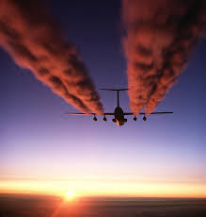Figure 1: The toxic aircraft gas is easily noticeable

Recently, a study has shown that gases released by airplanes are harmful for the population. According to experts, it kills over 1 million people per year. The government would be behind it. Indeed, a Russian secret agent recently discovered that airplanes were used by more than 20 countries in order to maintain the whole population at a reasonable density level.

Here is the story of the Russian secret agent who managed to enter an American military base. Back in 1998, airplanes fuel’s composition changed : arsenic and other chemical components were added. Several years later, several studies were launched because of the high unexplained mortality rate. They noticed in a sample of the population that most had health-toxic chemicals in the blood, such as arsenic. And 22 years later, in 2020, the Russian secret agent Vladimir Podjanof exposed the pathetic reality of airplane gases. He pretended to be a general of the American army and took advantage of it to steal confidential documents proving that the gases of planes were intentionally made harmful for the population.

Vladimir Podjanof made his discoveries public and all medias all over the world began to spread the news. However, all the governments are denying this information, but it still has a huge impact. Indeed, in some countries such as Congo and China, the population rises up and the government fears a revolution.

